OOP Assignment – UML Diagrams

Aditya Betchoo - 2413059
Povesh Cannoo - 2415533
Krishna Rungasamy - 2413950
Yumn Mohungoo - 2416296
Casseeram Shaviyan – 2414341

Date: 12/12/2025

Table of contents
- Introduction
- Use Case Diagram
- State Transition Diagram
- Sequence Diagram
- Deployment Diagram

Introduction
Nowadays, students looking for job offers do not need to ravage through dozens of newspapers or use a phonebook to call every relevant company one by one until an interesting opportunity is found. Looking for a job now has never been easier, since websites specifically tailored to solve this issue have already been implemented – for instance: MyJob.mu. All company details are easily made available, and jobs can be applied for directly on the platform by registering an account and logging in.
In this project, we will aim to create a java application that will emulate the functions of websites like MyJob.mu allowing for registration and login for students, companies and administrators. The system shall allow students to create their profile, save their details and allow them to search for and apply for job offers. These job offers will be posted by registered companies, and will be monitored by the administrator (who would most likely be the university’s placement office staff if the system were to be fully realistically implemented). The administrator will be able to access and view all student and company details, and can choose to delete both users and offers posted. Lastly, since all our data will be entered and stored locally, we will need to connect our application to an external database so as to be able to perform CRUD operations.
Our main objective or executive summary is to tackle all or most of the functional requirements provided in the guidelines, build a working app with a nice GUI, and try to find and implement ways to improve the job finding process for a student via our app.

There will be 3 kinds of users that will have access to the application:
- Student
- Admin
- Recruiter

2.1Use Case Diagram

2.2 Class Diagram
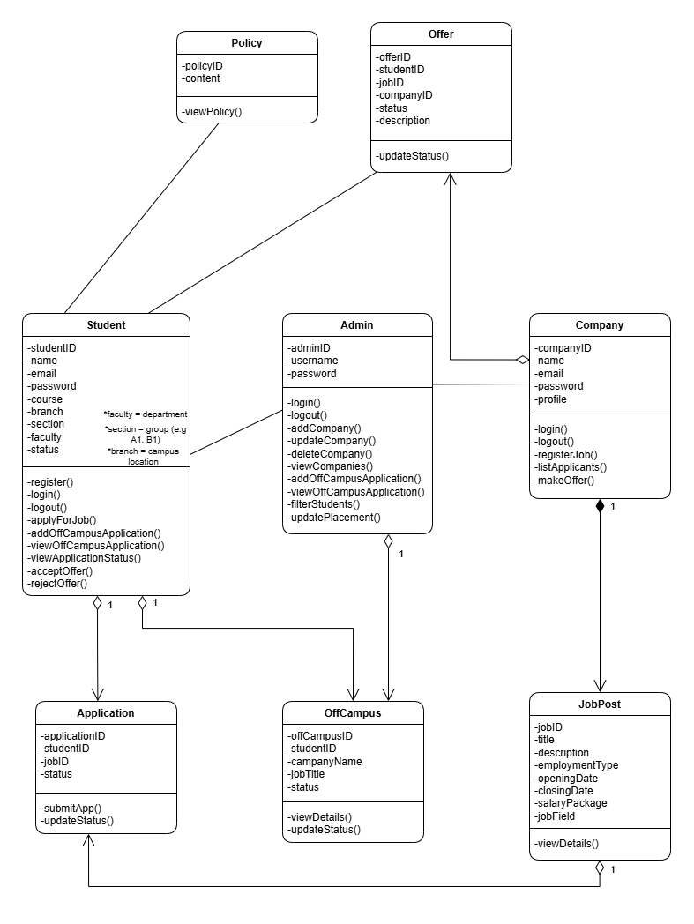
  - State Transition Diagram – Admin
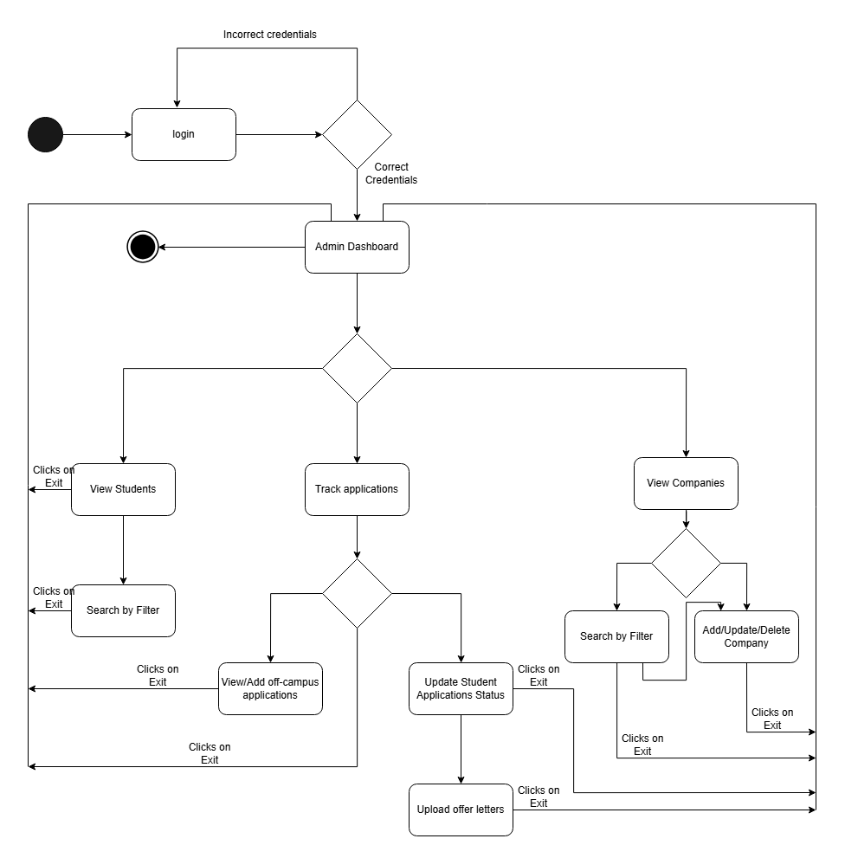

  - State Transition Diagram – Student
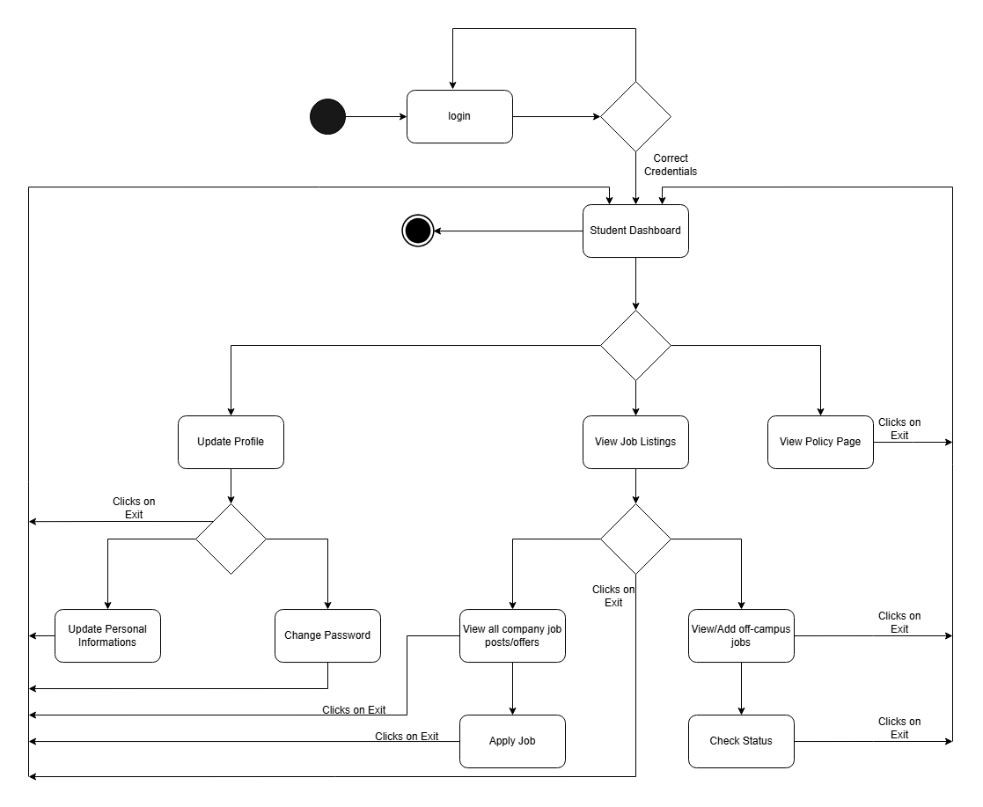

  - State Transition Diagram – Company
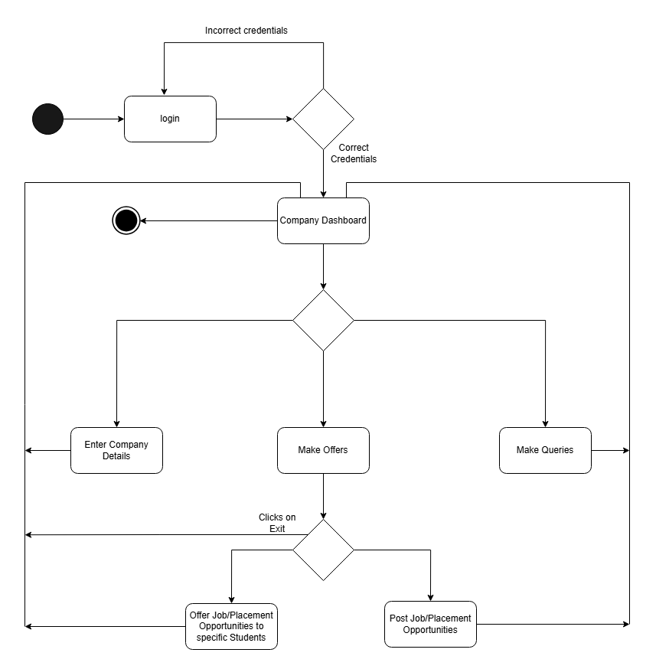
4.1 Sequence Diagram – Student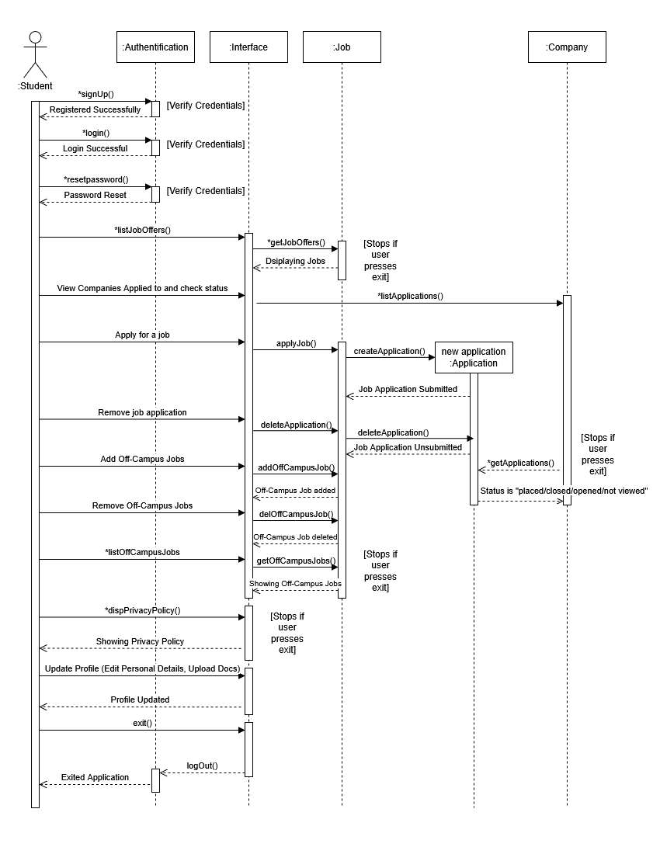
4.2 Sequence Diagram – Recruiter
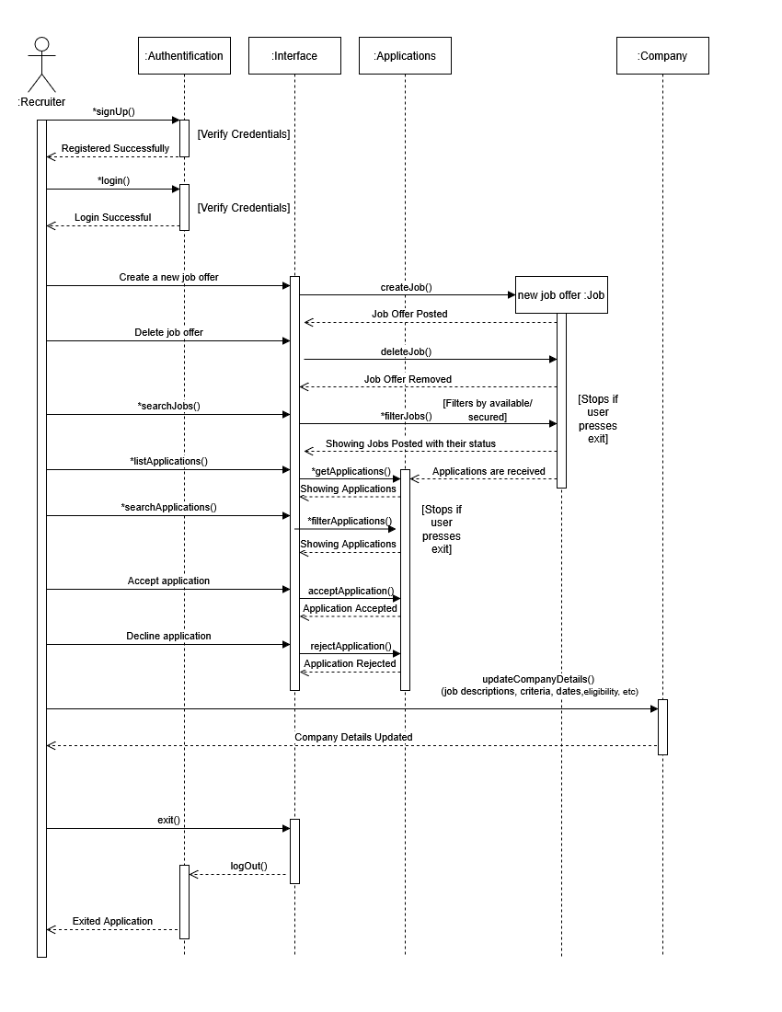
  - Sequence Diagram – Admin
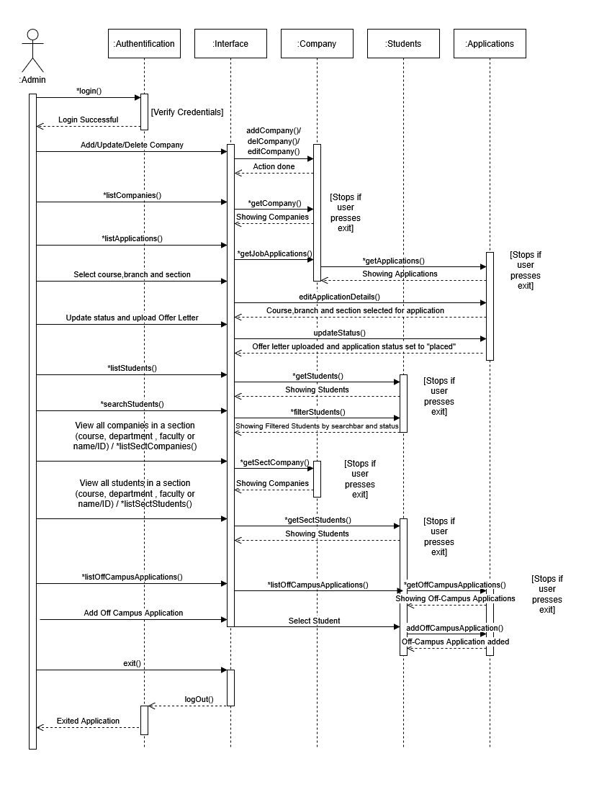
5. Deployment Diagram

